**The frequency at which South African savannas should be burned**

ABSTRACT

The aim of this study was to investigate the frequency at which savannas should be burned to maintain the co-occurrence of trees and grasses. My hypotheses were that (1) Pre-fire height would be taller than post-fire height for all the species, (2) Shorter trees would be more topkilled than taller trees, (3) smaller stems would be more topkilled than larger stems (4) trees with thinner bark would be more topkilled (5) a species will either have tall or numerous resprouts. To accomplish the aim, we collected height, circumference, bark thickness, number of resprouts, and height of the resprouts data for *A.davyi*, *D.cinerea*, *D.rotundifolia*, and *S.birrea* species. Moreover, we drew graphs that demonstrate how topkill changes with height, circumference, bark thickness, and species. And other graphs that represent the number of resprouts and height of resprouts for the species. Topkill was negatively correlated to height, circumference, and bark thickness, and *A.davyi* was the least topkilled species. Furthermore, *A.davyi* had taller resprouts and *D.rotundifolia* had more resprouts. The frequency of burning in a savanna should be determined by the species found in the area and the bark thickness size at which species escape topkill.

INTRODUCTION

The Savanna biome is characterized by the co-dominance of both trees and grasses (Scholes & Archer, 1997). Provided that vegetation of this biome is very intolerant to shade trees are scattered around and grasses form a uniform layer but are hardly found directly under the trees (Ratnam *et al*., 2011). Furthermore, in the biome grasses compete for resources especially for light with trees, as a result, grasses grow flammable fuels to promote tree mortality when fire burns (Ratajczak *et al*., 2017). Trees found in this biome are not only characterized by thicker bark but with buds on the roots and stem as well (Ratajczak *et al*., 2017). It is also worth noting that savannas found in the tropics have a mean annual temperature of < 10 ° C (Lehmann *et al*., 2011).

Disturbances such as fire in the biome maintain the co-dominance of trees and grasses (Hoffmann *et al*., 2020). Also, during fire events, the continuous grass layer fuels the fire to burn further and further killing the trees (Hoffmann *et al*., 2020). As a result, when trees are burned down grasses are favoured because the two vegetation types will then begin to grow from an equal height with reduced competition for light (Massi & Franco, 2016). Moreover, small trees usually become more topkilled in contrast to large trees and this is due to small trees being in the flame zone (Massi & Franco, 2016). In the event that trees are topkilled resprouting which is the only functional trait that enables trees to persist in a fire-prone environment becomes triggered (Charles-Dominique *et al*., 2015). Topkilled trees may resprout either from basal or below-ground buds and those not topkilled from aerial buds (Massi & Franco, 2016). After a fire event, trees then respond by either investing in numerous resprouts or in the height or width of their stem (Devine *et al*., 2015).

In savannas, humans ignite fires in intervals of 2-3 years (Hoffmann & Solbrig, 2002). This time frequency of burning is not long enough for trees to grow to reproductive size therefore trees get trapped in the growing phase and delay reproduction (Hoffmann, 1998). Given that fire is the only disturbance that significantly reduces woody cover, therefore, maintaining the co-occurrence of trees and grasses (Devine *et al*., 2015). There is a lack of knowledge about how frequently, at what scale, what season should savannas be burned to maintain the co-existence of grasses and trees. Some studies suggest that savannas be burned in frequencies of less than 3 years to keep the saplings in the flame zone to not out-compete grasses (Devine *et al*., 2015). On the other hand, some studies suggest increasing fire frequency as it enables grass fuel load to be abundant enough to promote a high fire intensity that would topkill numerous trees (Devine *et al*. 2015).

With all that has been mentioned, this study aims to investigate the frequency at which savannas should be burned. To accomplish this I will carry out the following objectives (1) compare pre- and post-fire tree height, (2) graphically analyze how tree topkill changes with height, circumference, species, and bark thickness (3) further analyze the tradeoffs of a species. My hypotheses are that (1) Pre-fire height will be taller than post-fire height for all the species, (2) Shorter trees will be more topkilled than taller trees, (3) smaller stems will be more topkilled than larger stems (4) trees with thinner bark will be more topkilled (5) a species will either have tall or numerous resprouts.

MATERIALS AND METHODS

*Study area*

The study was conducted at Wits University Pullen Nature Reserve located in Mpumalanga (31°10ʹ42.5ʹʹE, 25°34ʹ01.6ʹʹS), South Africa (Tocco *et al*, 2021). It is a 250-ha farm comprising trees, grasses, and herbivores therefore classified as a savanna biome. The area burns annually in patches and has a mean annual rainfall of 562 mm with February being the wettest month and August the driest month. Sampling was carried out from the 9th to the 13th of April 2023 between 8 am and 5 pm.

*Study species*

We sampled *Acacia davyi* N.E.Br., (Fabales: Fabaceae), *Dichrostachys cinerea* (L.) Wight & Arn, (Fabales: Fabaceae), *Dombeya rotundifolia* Hochst., (Malvales: Malvaceae), and *Sclerocarya birrea* A. Rich, (Sapindales: Anacardiaceae). Our choice of species was determined by the fact that these are the only abundant species in the area.

*Dichrostachys cinerea* is commonly known as the sickle bush (Pedroso & Kaltschmitt, 2012). It is a spiny deciduous tree made up of grey-brown fissures on the stem and old branches and consists of bipinnate leaves (Pedroso & Kaltschmitt, 2012; Randle *et al*., 2018). The species has a typical maximum height of 7 m and its thorns can be as long as 8 cm (Pedroso & Kaltschmitt, 2012). It is very tolerant of disturbances such as fire and overgrazing (Utaile *et al*., 2020). When it grows it forms a thicket as a result blocking sunlight from other plants such as grasses in the savanna (Randle *et al*., 2018).

*Dombeya rotundifolia* is a deciduous plant with dark grey-brown bark and grows up to 15 m to form a shrub or tree (Maroyi, 2018). It has alternate, ovate dark green leaves and dark brown corky bark and a maximum height of 10 m (Maroyi, 2018; SANBI, 2001). It is known as having a fire-resistant layer on the stem to protect itself in fire-prone environments (SANBI, 2001).

*Sclerocarya birrea* is commonly known as the marula tree (Mashau *et al*., 2022). It is a deciduous tree with grey bark and grey-green leaves (Mashau *et al*., 2022). This species may grow up to 1.5 m and is abundant in KZN, Mpumalanga, and Limpopo province, South Africa (SANBI, 2003).

*Acacia davyi* has yellowish-brown corky with yellow flowers in summer and bipinnate leaves and may reach a height of 3 m (Random harverst, 2023). It is widely distributed in high rainfall areas of KZN, Mpumalanga, and Limpopo, South Africa (Random harvest 2023).

*Experimental design and protocol*

We went to the field and examined the species found there and their abundance and size. Examining the area helped us decide on which species to sample. We sampled four species and two of those were broad-leaved and the other two were narrow-leaved. The number of species sampled was determined by the fact that there were only four species that were abundant enough to enable comparison both within and between species. We decided to sample 30 replicates for each species because we had limited time for data collection as we would collect, analyze, and present to our supervisors in a day. In 30 replicates we had 10 small, medium, and large individuals for fair comparison.

For each individual, we measured pre- and post-fire height using a 140 cm plastic rod with tape at intervals of 20 cm. We positioned the rod next to a tree, pre-fire height was measured from ground level up to a point where the highest new resprout grew from, and post-fire height was measured from ground level up to the end of the highest resprout. In a case where a tree was taller than 140 cm one person would position their hand at 140 cm and another would place the rod right next to the hand and count the height. For trees that were higher than 280 cm, we would place the rod right next to the tree and move far to the side of the tree and estimate how many of the 140 cm is the tree. Before and after fire height was measured to determine whether a tree invested in height or not after the fire.

In trees that were completely topkilled with no stem we would find their stems lying next to the resprouts then pin them on their visible roots/ remains and measure their pre-fire height, and post-fire height was the height of the highest resprout visible next to the remains. Furthermore, we measured the circumference of each tree to examine if there is a correlation between it and topkill. A measuring tape in centimeters was placed around the stem at a point just above any basal swelling and below branches and size was read and recorded. In topkilled trees, we also measured the circumference of the tallest resprout.

Moreover, we counted the number of resprouts each tree has to determine whether it invested in height or abundance after the fire. Further observed whether each individual has pods or flowers to determine if reproduction is the tradeoff or not. And estimated the percentage of canopy cover present in each tree. Lastly, we cut down five samples for each species just above basal swelling using a sew-saw. And further cut pieces of 0.1 cm at circumferences of 6, 8, and 12 cm in each tree. Trees were cut at these circumferences to measure a change in bark thickness. We measured the inner and outer bark thickness of the pieces with a calliper at the scientific laboratory.

*Data analyses*

Data were analyzed on R 3.5.1 (R Development Core Team, 2014). We calculated the percentage of topkill for each tree using the formula ((Prefire height – Height of resprout for topkill)/ Prefire height) * 100. Having the Topkill Percentage variable will allow me to draw graphs comparing how topkill changes with height, circumference, species, and bark thickness. I removed outliers in the variables that I used to draw graphs. I performed a one-tailed paired t-test for prefire and postfire height variables. A t-test is most suitable for comparing these variables because they are both continuous and it had to be one-tailed because I wanted to check if the mean of prefire height is indeed greater than that of postfire height as assumed. Comparing the two height variables will allow me to conclude whether burning reduced the height of the trees or not.

Furthermore, I performed a correlation test to find out how the prefire height and the prefire stem circumference change with the percentage of topkill. And also performed a correlation test for pre- and post-fire height to find out the kind of relationship these variables have. Performing a correlation test confirms the strength and type of relationship the variables have that we may be observing with our eyes. Moreover, I performed an ANOVA test for the species against the percentage of topkill, bark thickness, number of resprouts and height of the highest resprout. An ANOVA test will inform me how each of these variables changes with the species. Finally, I calculated the mean, standard deviation, or standard error for the continuous variables.

RESULTS

As hypothesized pre-fire height (mean ± SD = 1.83 ± 0.87 m) was significantly greater than post-fire height (1.57 ± 0.95 m; t103 = 4.99, P = 1.18e-6) (figure 1). I found a moderate negative linear correlation between the pre-fire height and the topkill percentage (0.75 ± 0.03) ( *r* = -0.55, t109 = -7, P = 2.10e-10) (figure 2). Similarly, the percentage of topkill and the pre-fire stem circumference (13.79 ± 11.49 cm) have a strong negative correlation ( *r* = -0.74, t106 = -11.37, P < 2.2e-16) (figure 3). Surprisingly, the percentage of topkill (mean ± SE = 0.75 ± 0.03) was not significantly different among the species (F3, 115 = 1.33, P = 0.27) (figure 4).

The species have significantly different total bark thicknesses (4.98 ± 0.23) with A.davyi exhibiting the thickest bark (F3,56 = 8.55, P = 9.11e-5) (figure 5). With all the results already mentioned above *A.davyi* is the only species that is resistant to topkill. Recovery in terms of the number of resprouts (3.54 ± 0.20) is significantly different among the species (F3,72 = 4.09, P = 0.01) (figure 6). *Dombeya* *rotundifolia* had more resprouts (max = 9 ) in contrast to the other species. Lastly, the height of the resprouts (3.54 ± 0.09) was not significantly different among the species F3,70= 3.76, P = 0.01) (figure 7). However, I think it is worth mentioning that *A.davyi*  had the tallest resprouts with a max of 2 m. Hence, *D.rotundifolia* invested in abundance and *A.davyi* in height.

Figure 1: The difference between the pre- and post-fire height of the four tree species. The height variables have a positive linear correlation of r = 0.63, t(102) = 8.26, p = 5.66e-13.

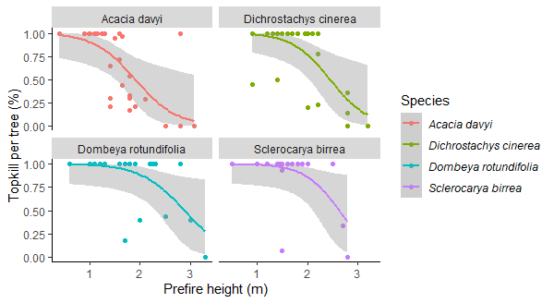

Figure 2: The relationship between the percentage of topkill and pre-fire height. Topkill decreases with height for all the species. *Acacia* *davyi* and *D.cinerea* escape topkill at a height of approximately 3 m.

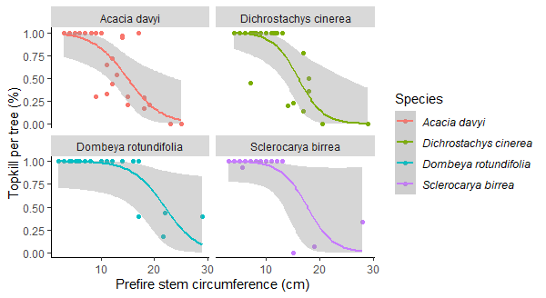

Figure 3: The relationship between the percentage of topkill and the pre-fire stem circumference. The topkill percentage decreases as stem circumference increases*. Acacia davyi* and *D.cinerea* escape topkill at approximately 25 cm.

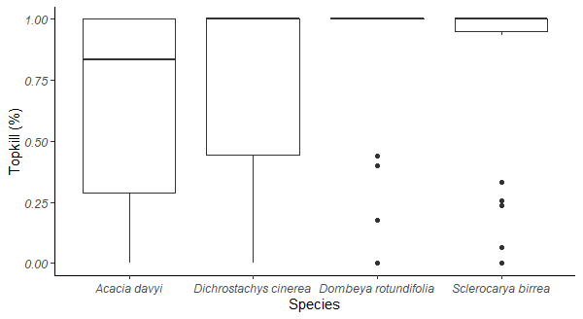

Figure 4: The relationship between the percentage of topkill and the species. The topkill percentage is negatively skewed for all the species. *Acacia davyi* has the most dispersed but *D.rotundifolia* has the least dispersed topkill percentage.

Figure 5: The total bark thickness for the species. A Tukey post-hoc test revealed differences between *S.birrea* and *A.davyi* with an average of -2.57 mm (p < 0.05) and between *D.cinerea* and *A.davyi* with an average of -2.09 mm (p < 0.05). *Acacia davyi* has the least dispersed bark thickness among the species. *Dombeya rotundifolia* is the only species with symmetric bark thickness data.

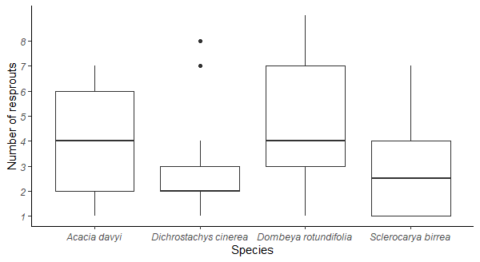

Figure 6: The difference in the number of resprouts for the species. A Tukey post-hoc test revealed differences between *D.rotundifolia* and *D.cinerea* with an average of 1.85 (p < 0.05) and between *D.rotundifolia* and *S.birrea* with an average of -1.92 (p <0.05). *Acacia davyi* and *S.birrea* have symmetrical but *D.cinerea* and *D.rotundifolia* have positively skewed data for the number of resprouts.

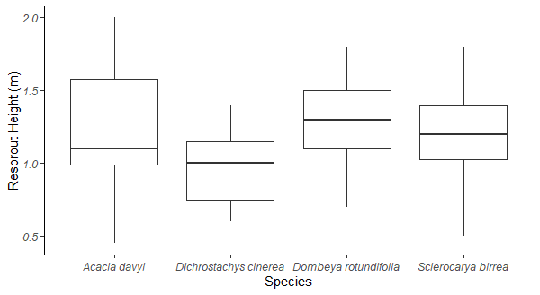

Figure 7: The height of the highest resprout for the species. *Acacia davyi* has the most dispersed height of resprout. *Dombeya rotundifolia* and *S.birrea* have symmetrical heights of resprout.

DISCUSSION

As mentioned in the introduction, I am trying to investigate how topkill changes with height, circumference, species, and bark thickness. Moreover, find out how each species responds to fire. The pre-fire height was significantly taller than the post-fire height though these variables had a positive relationship (figure 1). This implies that fire greatly reduced the height of trees but not below their prefire height. Moreover, as expected the topkill percentage decreased with the pre-fire height from 100 to 0 % (figure 2). *Acacia davyi* and *D.cinerea* started to escape topkill from a height of 1 m whilst *D.rotundifolia* and *S.birrea* started from 2 m (figure 2). At a height of approximately 3 m the former had completely escaped, and the latter seemed as if it would completely escape at approximately 4-5 m.

This pattern was expected as some trees were too tall for the flame to reach their crown and topkilled them. From my results, I think it will be effective to burn before the trees reach a height of 1 m to ensure that an abundant number of them become topkilled. Similarly with prefire stem circumference, *A.davyi*, and *D.cinerea* instantly escape topkill than *D.rotundifolia* and *S.birrea* (figure 3). The former started off to escape at approximately 10 cm and completely escaped at approximately 25 cm, while the latter started off at approximately 15 cm and completely escaped at approximately 30 m. Therefore, the area should be burned before the stem circumferences reach a maximum of 15 cm for a large number of trees to be topkilled.

The distribution of the topkill data shows that a larger portion of *D.rotundifolia* and *S.birrea* trees were more than 80% topkilled when overlooking the outliers, on the other hand, those of *A.davyi* and *D.cinerea* had a range between 0 and 100 % (figure 4). The latter better survived topkill because they resist topkill at smaller sizes as mentioned earlier. Therefore, to determine when to burn, we should use the height and circumference of *A.davyi* and *D.cinerea* as our measure. Furthermore, trees of *A.davyi* had the thickest bark and those of *S.birrea* had the thinnest bark (figure 5). Hence, I can now add bark thickness as another factor that could have caused *A.davyi* to better resist topkill. And even at 3 m the graph of *S.birrea* did not seem as if it was soon going to reach topkill escape, therefore it is possible that comprising a thinner bark caused it to be topkilled even at taller heights.

Some studies have found that bark thickness enables savanna trees to resist fire especially at smaller sizes (Bond & Keeley, 2005; Ratnam *et al*., 2011; Hoffmann *et al*., 2012). Moreover, trees with thicker bark have their vascular tissues and buds protected from fire and therefore better withstand topkill (Nolan *et al*., 2020). With this, we can conclude that *A.davyi* indeed resisted topkill because its buds were protected by its thicker bark. Also, bark properties such as bark density and moisture content play a major role in protecting trees from topkill (Nolan *et al*., 2020). Unfortunately in this study, I did not measure these variables therefore we cannot consider them for topkill.

Furthermore, exhibiting a thicker bark has been found to be one of the strategies adopted by trees in savannas with very frequent fires (Nolan *et al*., 2020). Therefore it seems as if bark thickness is the most important factor than height or circumference when looking at when to burn, because the thicker the bark the easier it is for trees to escape topkill. We observed that *D.rotundifolia* is one of the species that suffered the most topkill, but during recovery, this species invested more in abundance than height, and *A.davyi* prioritized height over abundance (Figures 6 & 7). Some studies have found that *S.birrea* does not really invest in abundance as it is known as a single-stem tree (Nyoka *et al*., 2015). Also, species with thin bark tend to resprout slower as a result may appear to have fewer resprouts (Nefabas & Gambiza, 2007). We remember S.birrea had the thinnest bark however its range of the number of resprouts is spread out.

Some problems that may have altered the results are that; (1) Post-fire height was measured from ground level to the end of the tallest resprout in partially topkilled trees but in completely topkilled trees we measured it as the height of the tallest resprout. This caused partially topkilled trees to have a higher post-fire height. (2) For some variables we had too many outliers and by removing them we remained with smaller data. In future studies, the sample size should be increased and the data should be evenly distributed. And also, measure bark density and moisture content to observe if it has an effect on topkill. Lastly, find a better procedure for measuring topkill in partially topkilled trees or exclude them by only measuring those topkilled and those not topkilled.

I did not gather much information about the effect of height and circumference on topkill however, I did observe in my results that trees with shorter heights or smaller circumferences suffered the most topkill. Furthermore, during recovery some species invested in height while some in abundance. I cannot generalize about when to burn a savanna because it depends on the species found in each. However, to be precise about when to burn a particular savanna to maintain the co-occurrence of grasses and trees we should carefully monitor the bark thickness, height, and diameter of the species after each fire to understand the sizes at which they escape topkill and burn before that size is reached.

REFERENCES

1. Bond, W.J., and Keeley, J.E. 2005. Fire as a global ‘herbivore’: the ecology and evolution and evolution of flammable ecosystems. Trend in ecology and evolution 20, 387-94.
2. Charles-Dominique, T., Midgley, G.F., Bond, W.J. 2017. Fire frequency filters species by bark traits in a savanna-forest mosaic, Journal of vegetation science28, 728-735.
3. Devine, A.P., Stott, I., McDonald, R.A., Maclean, I.M.D. 2015. Woody cover in wet and dry African savannas after six decades of experimental fires, Journal of Ecology 103, 473-478.
4. Hoffmann, W.A., Geiger, E.K., Gotsch, S.G., Rossatto, G.R., Silva, L.C.R., Lee Lau, O., Haridasan, M., Franco, A.C. 2012. Ecological thresholds at the savanna-forest boundary: how plant traits, resources and fire govern the distribution of tropical biomes, Ecology Letters 15, 759-68.
5. Mashau, M.E., Kgatla, T.E., Makhado, M.V., Mikasi, M.S., Ramashia, S.E. 2022. Nutritional composition, polyphenolic compounds and biological activities of marula fruit (*Sclerocarya birrea*) with its potential applications: a review, International journal of food properties 25, 1549-1575.
6. Maroyi, A. 2018. Dombeya rotundifolia (Hochst.) Planch.: review of its botany, medicinal uses, phytochemistry, and biological activities, Journal of complementary medicine research 9, 74-82.
7. Nolan, R.H., Rahmani, S., Samson, S.A., Simpson-Southward, H.M., Boer, M.M., Bradstock, R.A. 2020. Bark attributes determine variation in fire resistance in resprouting tree species. Forest Ecology and Management 474, 118-385.
8. Nefabas, L.L., Gambiza, J. 2007. Fire tolerance mechanisms of common woody plant species in a semiarid savanna in south western Zimbabwe. African Journal of Ecology 45, 550-556.
9. Nyoka, B.I., Chanyenga, T., Mng’omba, S.A., Akinnifesi, F.K., Sagona, W. 2015. Variation in growth and fruit yield of populations of Sclerocarya birrea (A.Rich.) Hochst. Agroforest system 89, 397-407.
10. Pedroso, D.T., Kaltschmitt, M. 2012. *Dichrostachys cinerea* as a possible energy crop-facts and figures, Biomass conversion and biorefinery 2, 41-51.
11. R Core Team (2014). R: A language and environment for statistical computing. R Foundation for Statistical Computing, Vienna, Austria. URL [http://www.R-project.org/](http://www.r-project.org/)
12. Randle, M., Stevens, N., Midgely G. 2018. Comparing the differential effects of canopy shading by *Dichrostachys cinerea* and *Terminalia sericea* on grass biomass, South African Journal of Botany 119, 271-277.
13. Random harvest, available from: [Acacia davyi Kurkbasdoring, Papierdoring, Kurkdoring Musaunga Isikhwishi Cork-bark Thorn, Corky Thorn, Paper-bark Thorn, Paper Thorn, Paper-bark Tree (randomharvest.co.za)](https://www.randomharvest.co.za/South-African-Indigenous-Plants/Show-Plant/PlantId/4/Plant/Acacia-davyi?Filter=All) (Accessed 14 June 2023j).
14. Ratajczak, Z., D’ Odorico, P., Yu, K. 2017. The enemy of my enemy hypothesis: Why coexisting with grasses may be an adaptive strategy for savanna trees, Ecosystems 20, 1278-1295.
15. Ratnam, J., Bond, W.J., Fensham, R.J., Hoffman, W.A., Archibald, S., Lehmann, C.E.R., Anderson, M.T., Higgins, S.I., Sankaran, M. 2011. When is a ‘forest’ a savanna, and why does it matter? Global Ecology and Biogeography 20, 653-660.
16. SANBI (2003) *Sclerocaraya birrea*, available from: [Sclerocarya birrea | PlantZAfrica (sanbi.org)](http://pza.sanbi.org/sclerocarya-birrea) (Accessed 14 June 2023).
17. SANBI (2001) *Dombeya rotundifolia*, available from: [Dombeya rotundifolia | PlantZAfrica (sanbi.org)](http://pza.sanbi.org/dombeya-rotundifolia) (Accessed 14 June 2023).
18. Scholes, R.J., & Archer, S.R. 1997. Tree–grass interactions in savannas. Annual Review of Ecology and Systematics 28, 517– 544.
19. Utaile, Y.U., Honnay, O., Muys, B., Cheche, S.S., Helsen, K. 2020. Effect of *Dichrostachys cinerea* encroachment on plant species diversity, functional traits and litter decomposition in an East-African savannah ecosystem, Journal of vegetation science 32, 29-49.